 **Project Report Template**

# 1 INTRODUCTION

* 1. Overview

Lacking knowledge and experience in cost estimating can lead to inaccurate, incomplete, or unrealistic cost estimates for your projects. This can endanger the success of your projects. Some of the consequences of poor cost estimating are: Schedule delays resulting from not having enough resources.

* 1. Purpose

Estimating Increases Profitability for Your Business

A multitude of factors, such as unexpected events, insufficiently scoped work, and inflation, can raise job costs over time, endangering the project's ability to be completed on time, under budget, and in line with profitability objectives.

**2 Problem Definition & Design Thinking**

2.1 Empathy Map

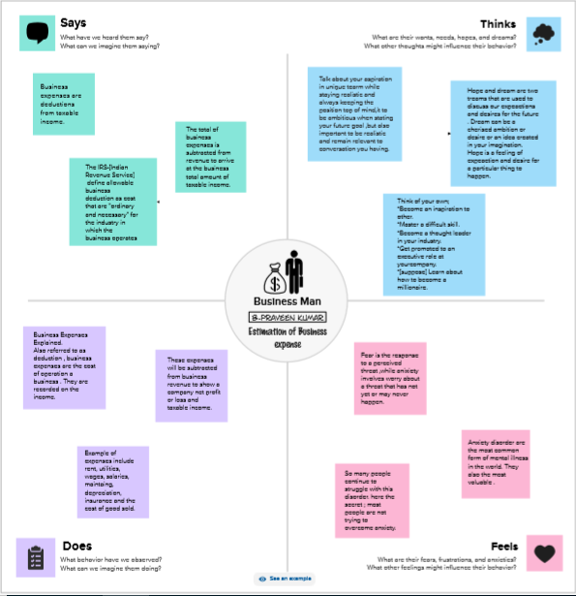

2.2 Ideation & Brainstorming Map

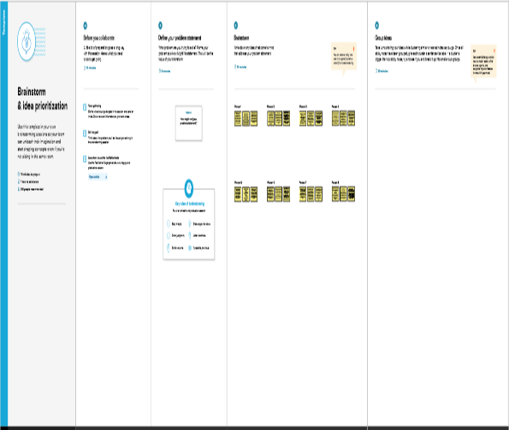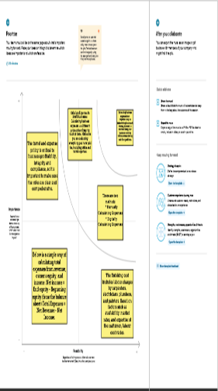 **RESULT**

Reduce profits and therefore reduce equity via retained earnings.

# 4 ADVANTAGES & DISADVANTAGES

**Advantages**

1. *Financial Control:* Helps small businesses manage

spending effectively.

1. *Budgeting:* Facilitates the creation of budgets to avoid

overspending.

1. *Performance Evaluation:* Allows assessment of financial

health and profitability.

**Disadvantages**

1. *Inaccuracy:* Estimations may not always reflect actual

costs, leading to budget shortfalls.

1. *Time-Consuming:* Creating detailed expense estimates

can be time-intensive for small businesses.

1. *May Not Account for All Costs:* Hidden or unexpected

costs may not be included in estimates.

# 5 APPLICATIONS

# Budgeting:It helps in creating and managing budgets to

# control costs effectively. Estimations inform pricing

# decisions to ensure profitability.

1. **\*Tax Planning:\*** Estimating expenses is crucial for tax planning and compliance.
2. **\*Strategic Decision-Making:\*** It supports strategic choices on

growth and expansion.

1. **\*Legal and Regulatory Compliance:\*** Ensuring compliance with financial regulations and reporting requirements. Overall, expense estimation is integral to financial stability and the success of a business.

# 6 CONCLUSION

1. In conclusion, estimating business expenses is a fundamental

practice for effective financial management. It enables businesses to plan, budget, and make informed decisions, leading to financial stability and growth. While there are challenges like potential inaccuracies and time-consumption, the advantages, including cost control, resource allocation, and risk management, far outweigh the disadvantages.

1. Continuous monitoring and adjustment of expense estimates are essential to adapt to changing economic conditions and ensure the financial health and success of a business.

# 7 FUTURE SCOPE

Automation: Expense estimation processes will become more

automated, saving time and reducing errors in calculations.

# 8 APPENDIX

Market Research: Attach market research reports or competitor

data that influenced your expense estimates.